**Sprint-1**

|  |  |
| --- | --- |
| **DATE** | **6 November 2022** |
| **Team Id** | **PNT2022TMID13490** |
| **Project Name** | **Gas Leakage Monitoring and Alerting System** |

**Analysing the Gas Leakage:**

#include <LiquidCrystal.h>

LiquidCrystal lcd(2,3,4,5,6,7);

#include <SoftwareSerial.h>

int val = A0;

void setup()

{ pinMode (9,OUTPUT); pinMode (A0,INPUT); Serial.begin(9600);

}

void loop()

{

val = analogRead (A0); if (val <500 )

{digitalWrite (9, LOW);} else

{digitalWrite(9, HIGH);}

}

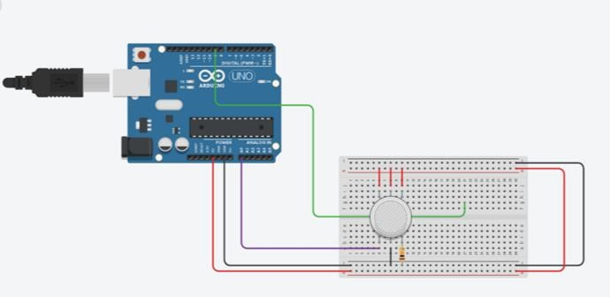

**Preventing From Explosion:**

The fire officers worry about any explosions due to gas leakage which may cause many death.

To use this gas leakage monitoring and alerting system is to prevent from more issues and product loss.